DriverPass System Design Document
Jailyn Mays
UML Diagrams
Use Case Diagram
This diagram shows how customers and staff interact with the system to complete key actions.
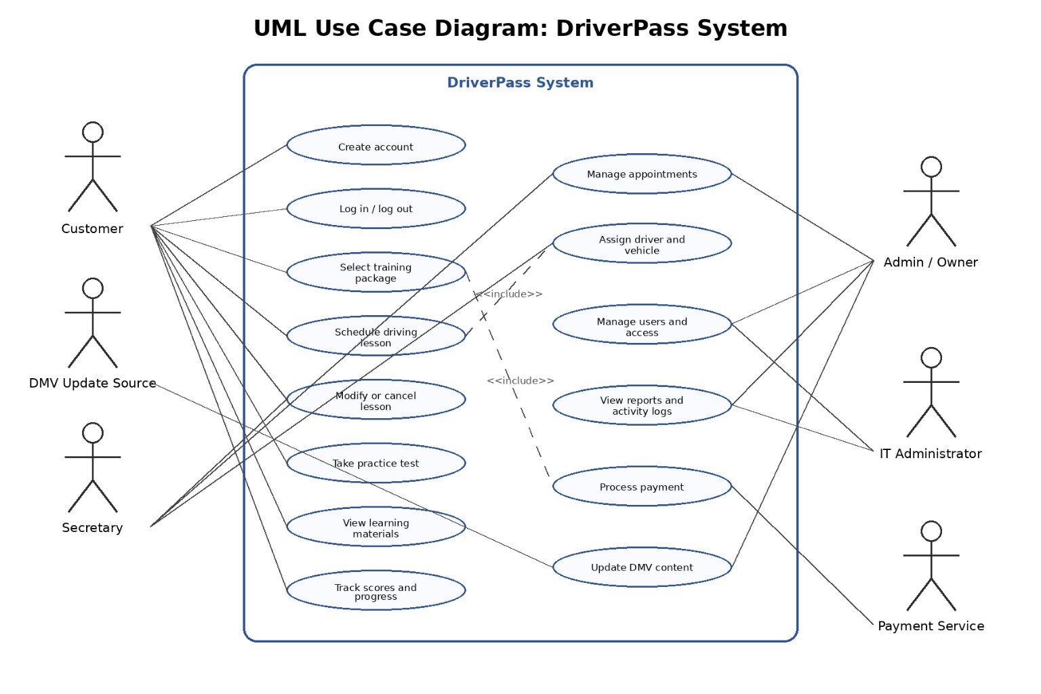
Activity Diagram: Schedule Driving Lesson
This diagram explains how a customer schedules a lesson from start to finish.
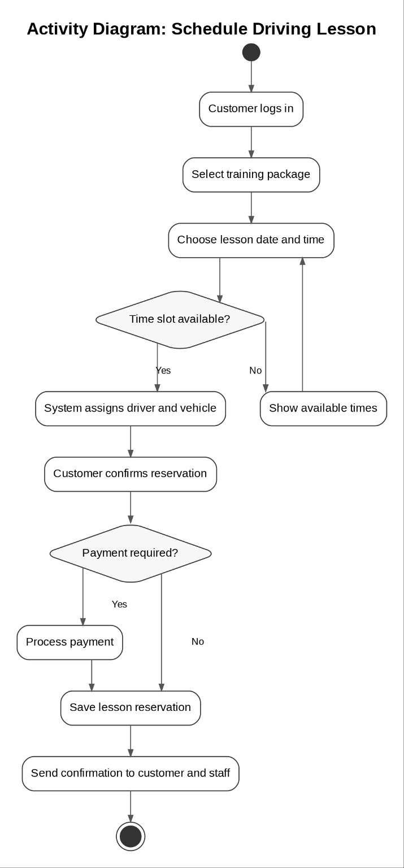
Activity Diagram: Take Practice Test
This diagram shows the steps involved when a customer takes a practice test.
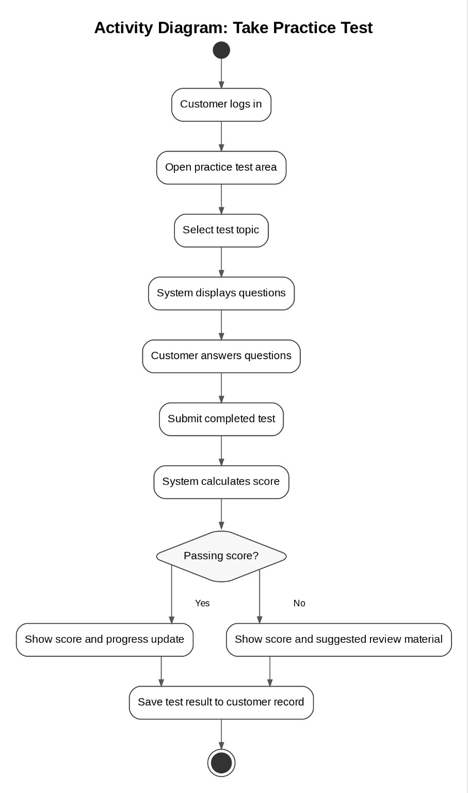
Sequence Diagram
This diagram shows how different parts of the system communicate when scheduling a lesson.
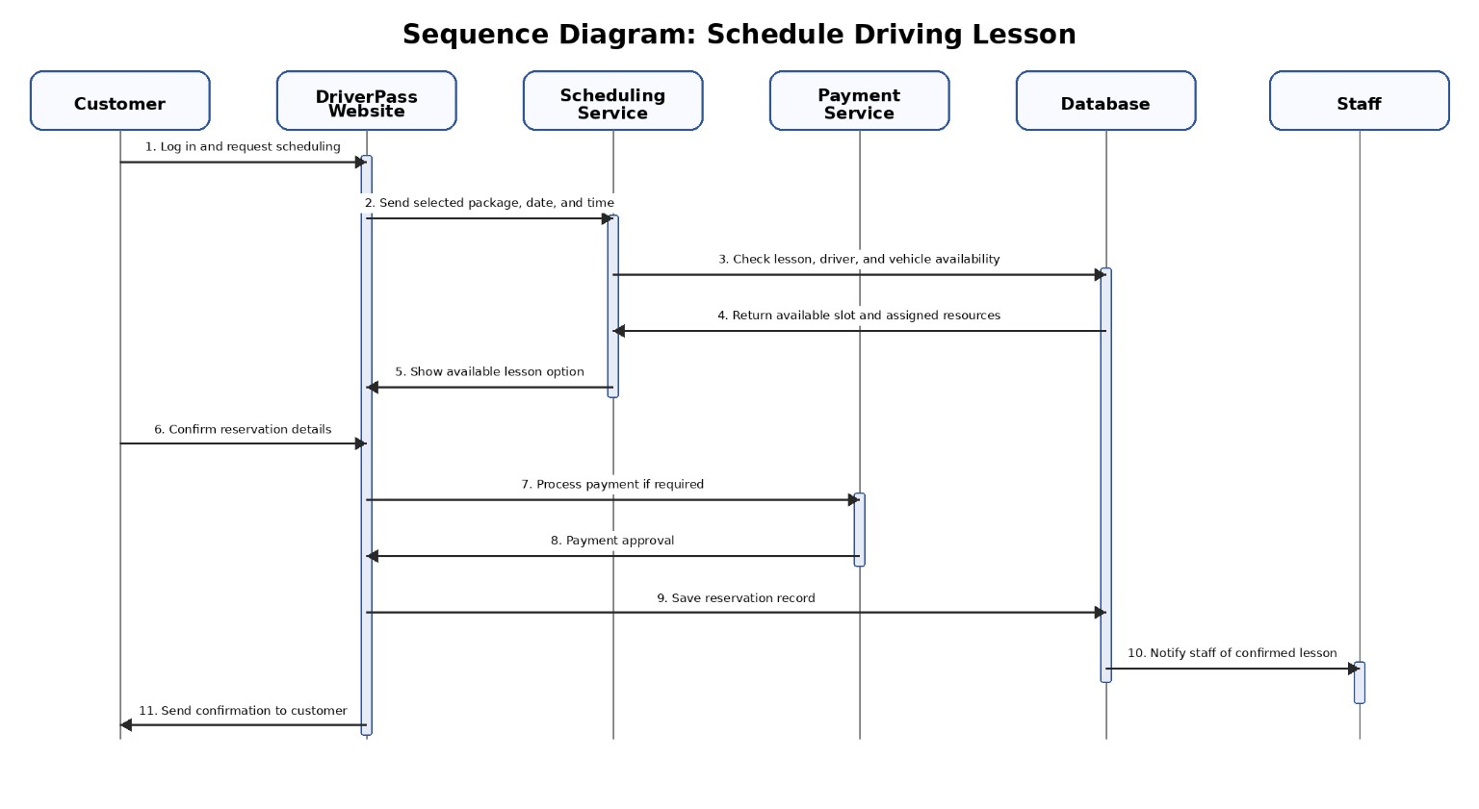
Class Diagram
This diagram shows how the system is structured and how different data is connected.
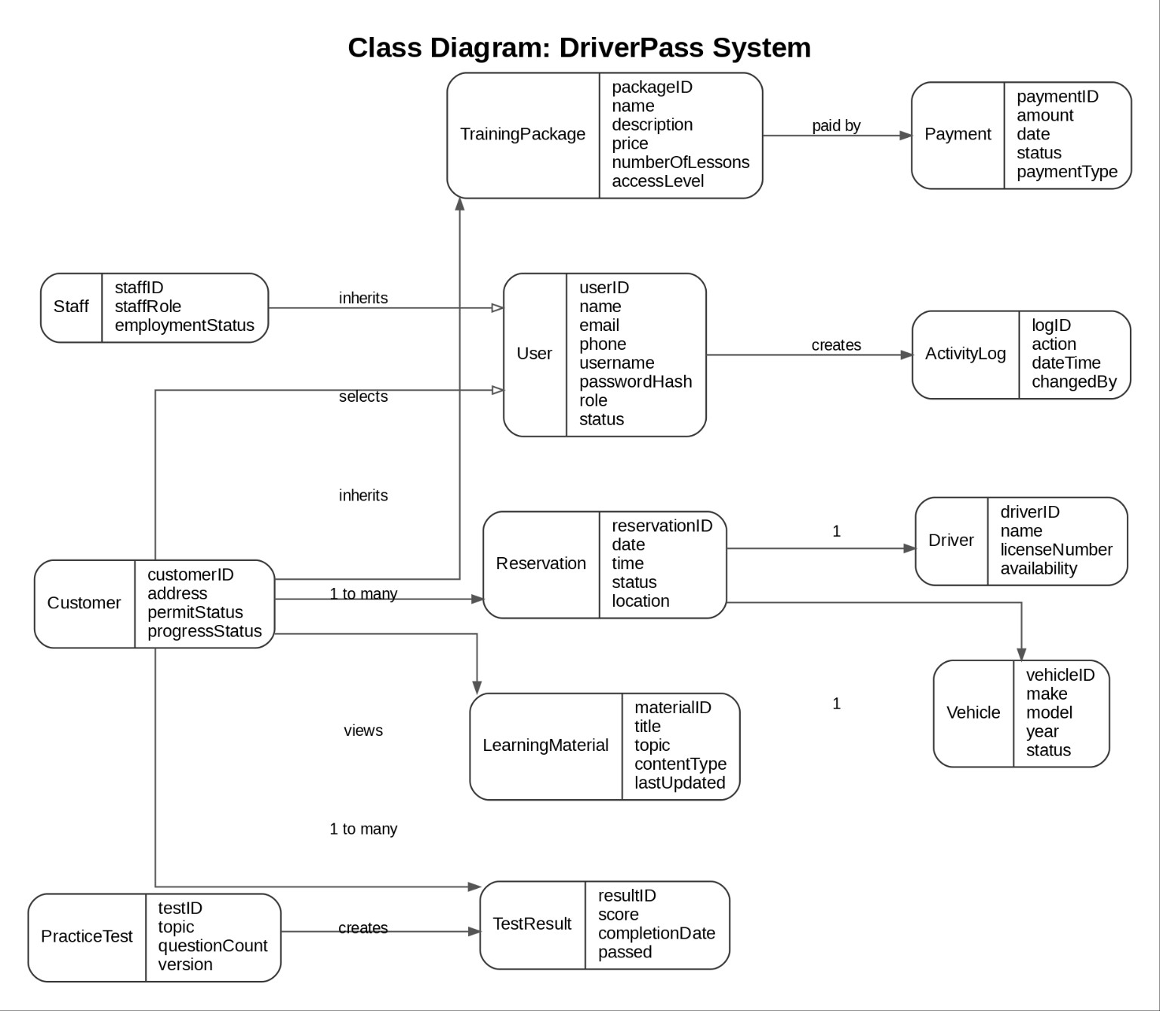
Technical Requirements
Hardware Requirements:
- Users must have a smartphone, tablet, or computer with internet
- Staff should have access to desktop systems
- Cloud servers will support system operations
Software Requirements:
- Web browsers such as Chrome or Safari
- Backend application for processing requests
- Database system for storing data
- Payment processing integration
Infrastructure:
- 24/7 availability
- Real-time updates
- Secure encrypted connections
- Backup and recovery systems

